**UNRAVEL THE MYSTERIES OF**

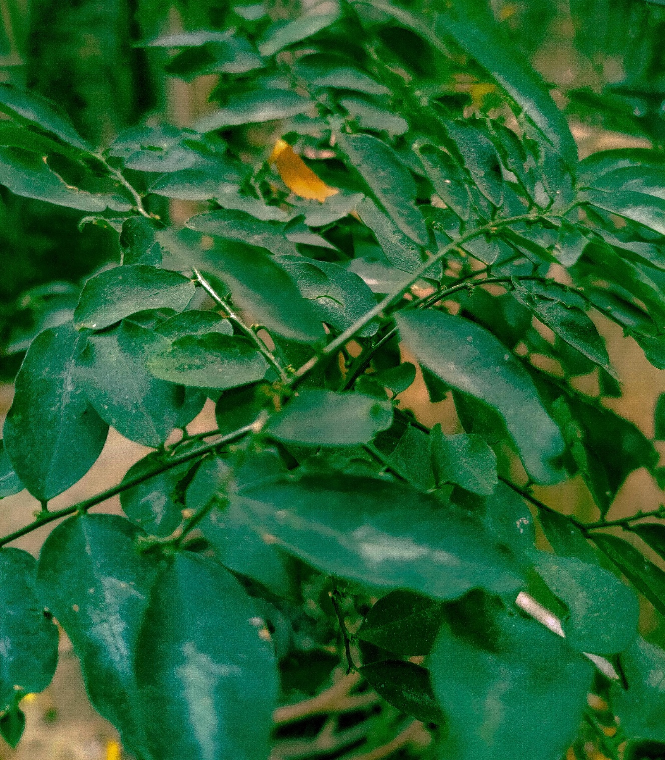 **NYCTINASTY**

**Justicia tranquebariensis**

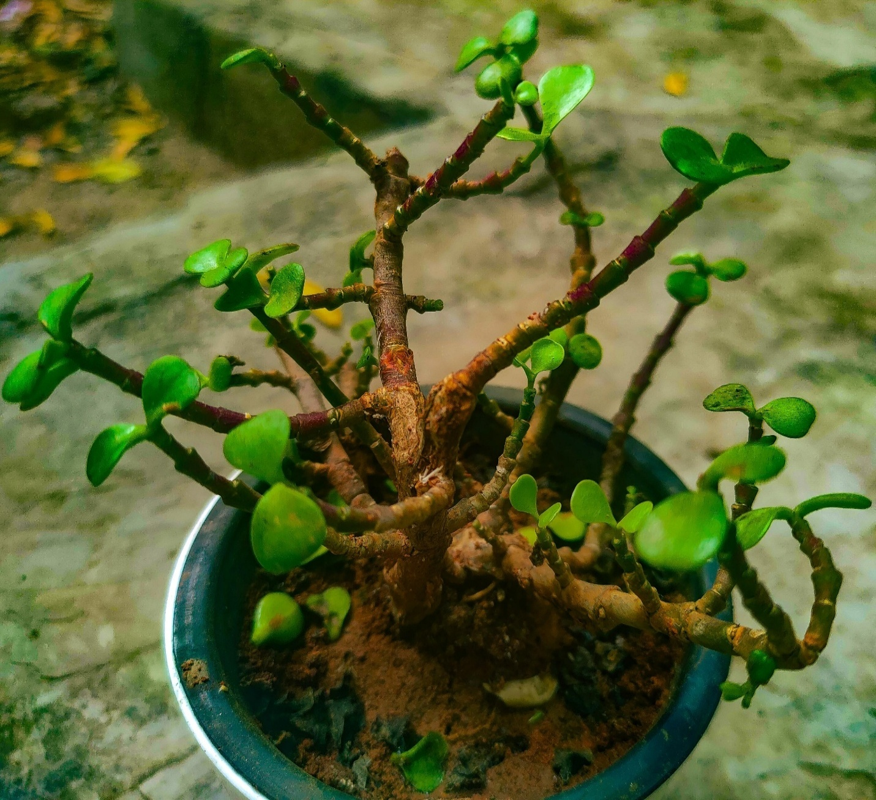

**Croton**

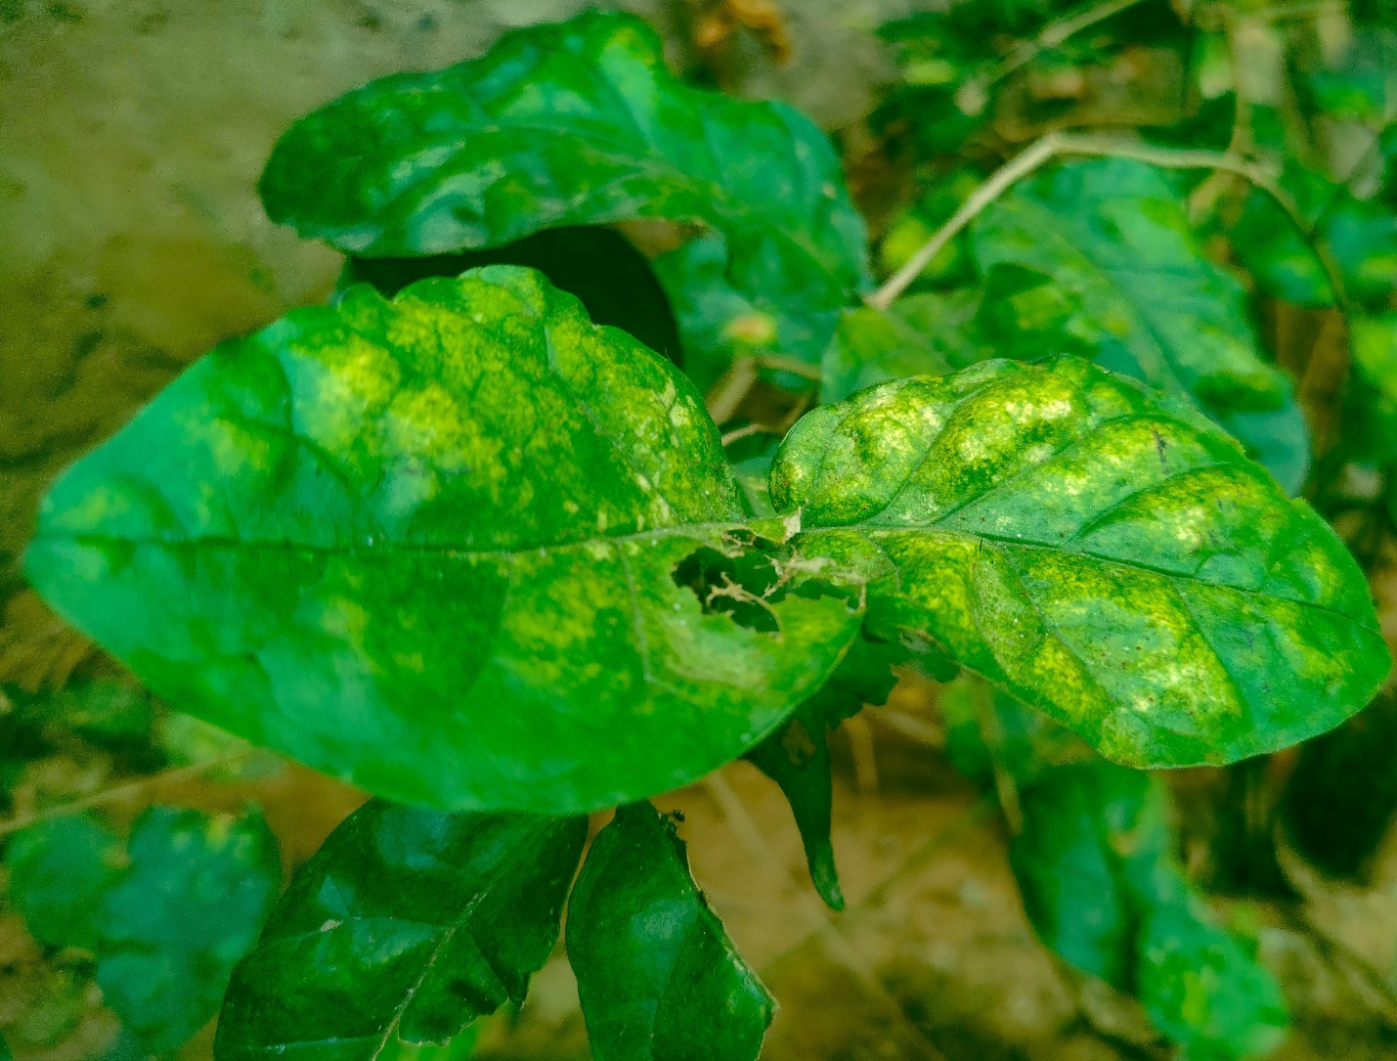

**Jasmin**

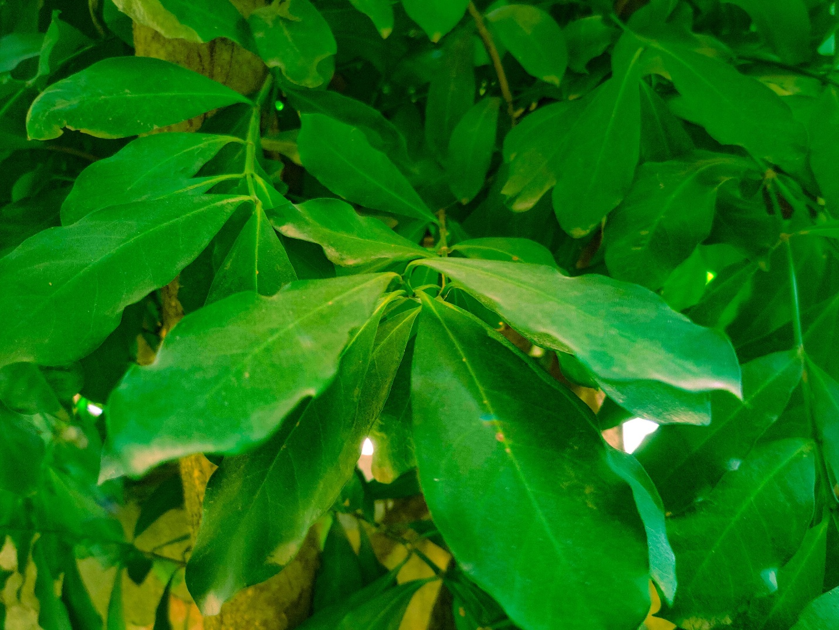

**Jungle Geranium**

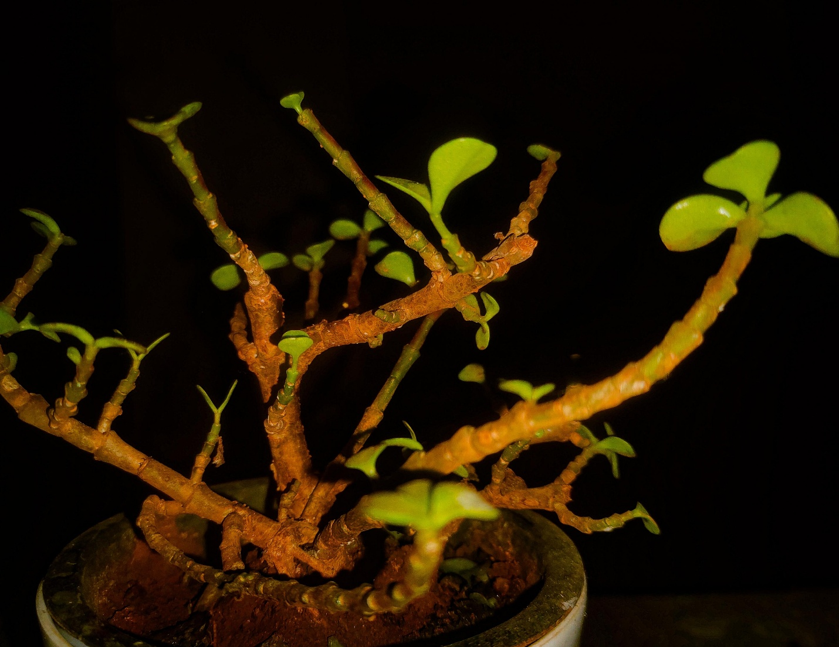

**Croton at night**

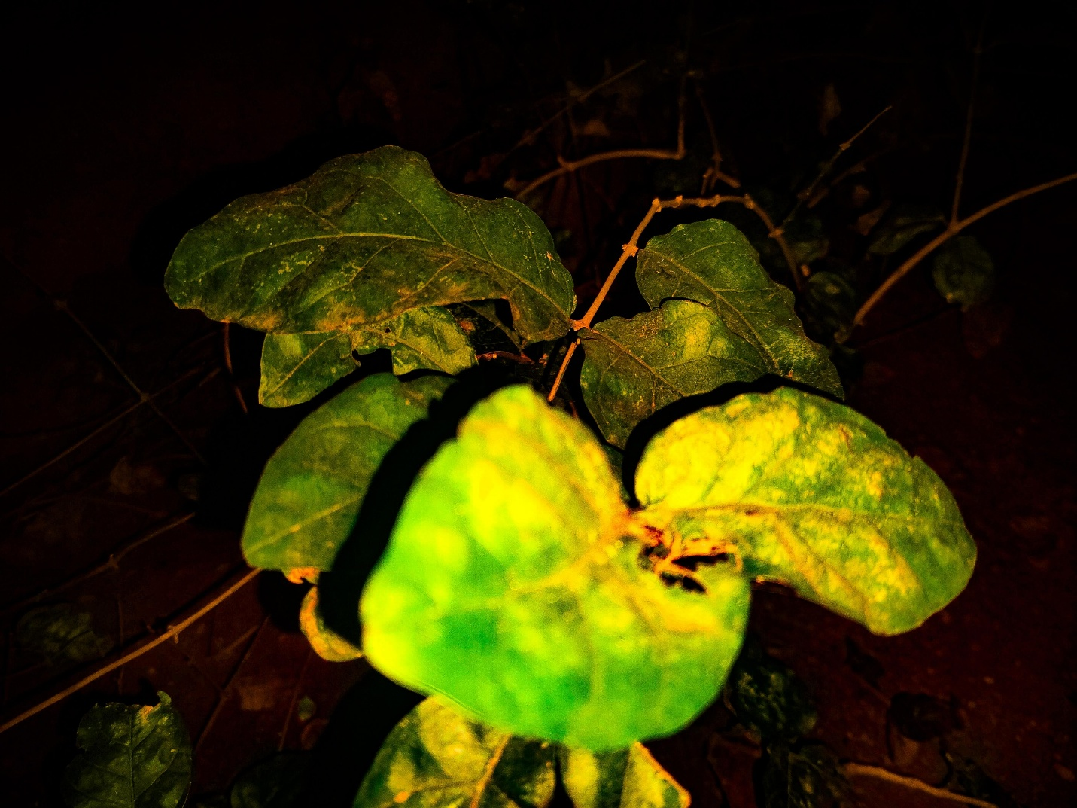

**Jasmine at night**

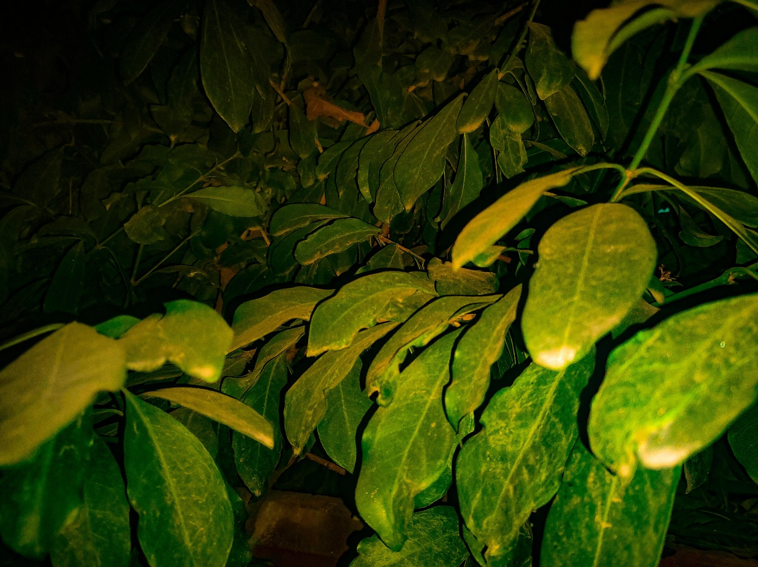

**Jungle geranium at night**

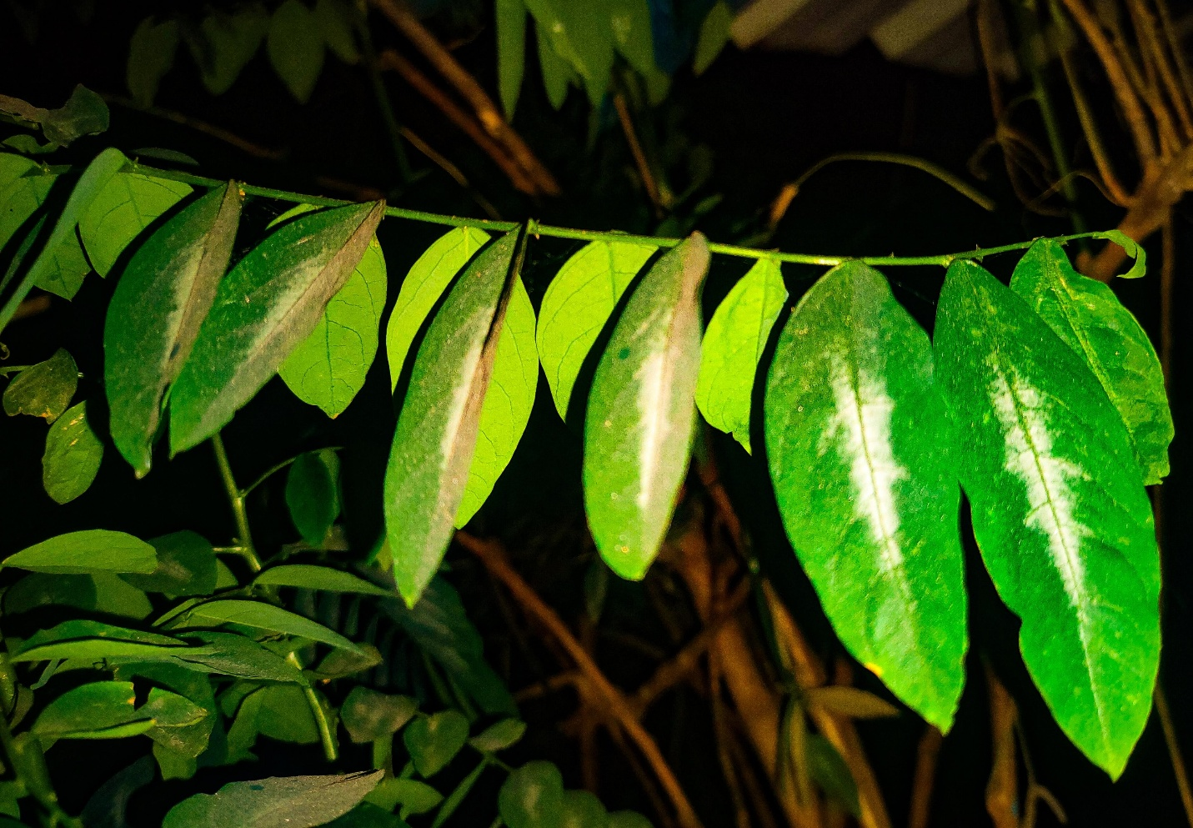

**Justicia Tranquebariensis at night ( leaves are closed)**

In a recent experiment, I observed the nyctinastic behaviour of certain plants from dawn till dusk. In a nutshell, nyctinasty is opening and closing of leaflets, petals or flowers in response to changes in light. The experiment commenced at dawn, I closely documented four plants, Jungle Geranium, Jasmine , Justicia Tranquebariensis and croton and their position. Once every hour until dusk i observed each plant keenly to see if there's any perceptible change. I repeated the process for several days to ensure if there is any change in observed patterns, while Jungle geranium, Jasmine and Croton were homogeneous from dusk until dawn, on the other hand Justicia Tranquebariensis exhibited a distinctive behaviour. As the sun went down Justicia Tranquebariensis' leaves gradually closed crafting a visually impactful metamorphosis. So, what is this, what is the cause behind this?

This nyctinastic behaviour is observed in certain plants including Justicia Tranquebariensis due to various factors but primarily the onset of darkness.

certain plants follow circadian rhythms which follows an internal biological clock that regulates various physiological and behavioural change in a 24 hour cycle. And other cases, closing leaves at night could be for protection, water conservation and temperature. Closing leaves during night can be measure taken in order to keep themselves safe from potential nocturnal pests, closing leaves during night can help the plants reduce water loss during transpiration at night usually when the temperature cools down, on the other hand by closing their leaves it will keep them warm at night just like we use blankets.The captivating behaviour witnessed in Justicia Tranquebariensis highlights the intricate ways in which plants adapt to their surroundings, the remarkable strategies plants employ for survival. Isn't that enchanting ? they have a life just like us, distinctive from ours yet strikingly beautiful.